Guidelines for Creation of Findings/Recommendations/SIIs/Comments

in SAP-SAM by interns

Guidelines Owner: Isabelle Peiffer/CBL Intern

Findings
To help auditors, interns (you) may be asked to create the findings/recommendations/comments in SAP-SAM. The AiC will contact &IA_Reporting asking for some support and will provide the final audit report before issuance.
Before you start creating the findings/recommendations/SIIs/comments,
- Ask the AiC to provide you with the following information that is not included in the report:
  - The responsible auditor for each recommendation
  - which recommendation is IT related in business audit report (so that GITA can be selected as relevant ‘legal entity’)
  - The ICS processes to be linked to each finding
- Double check that the audit related working papers have been uploaded and approved in SAP-SAM

Once the above-mentioned information is received, you can start.

- Log on to SAP-SAM.
- Ensure to be part of the audit team.
- If you are, the audit will be available in “My Ongoing Audits”.
- If not available, you can add yourself. To do so, click on “Track Ongoing Audits” and search for the audit you are interested in.
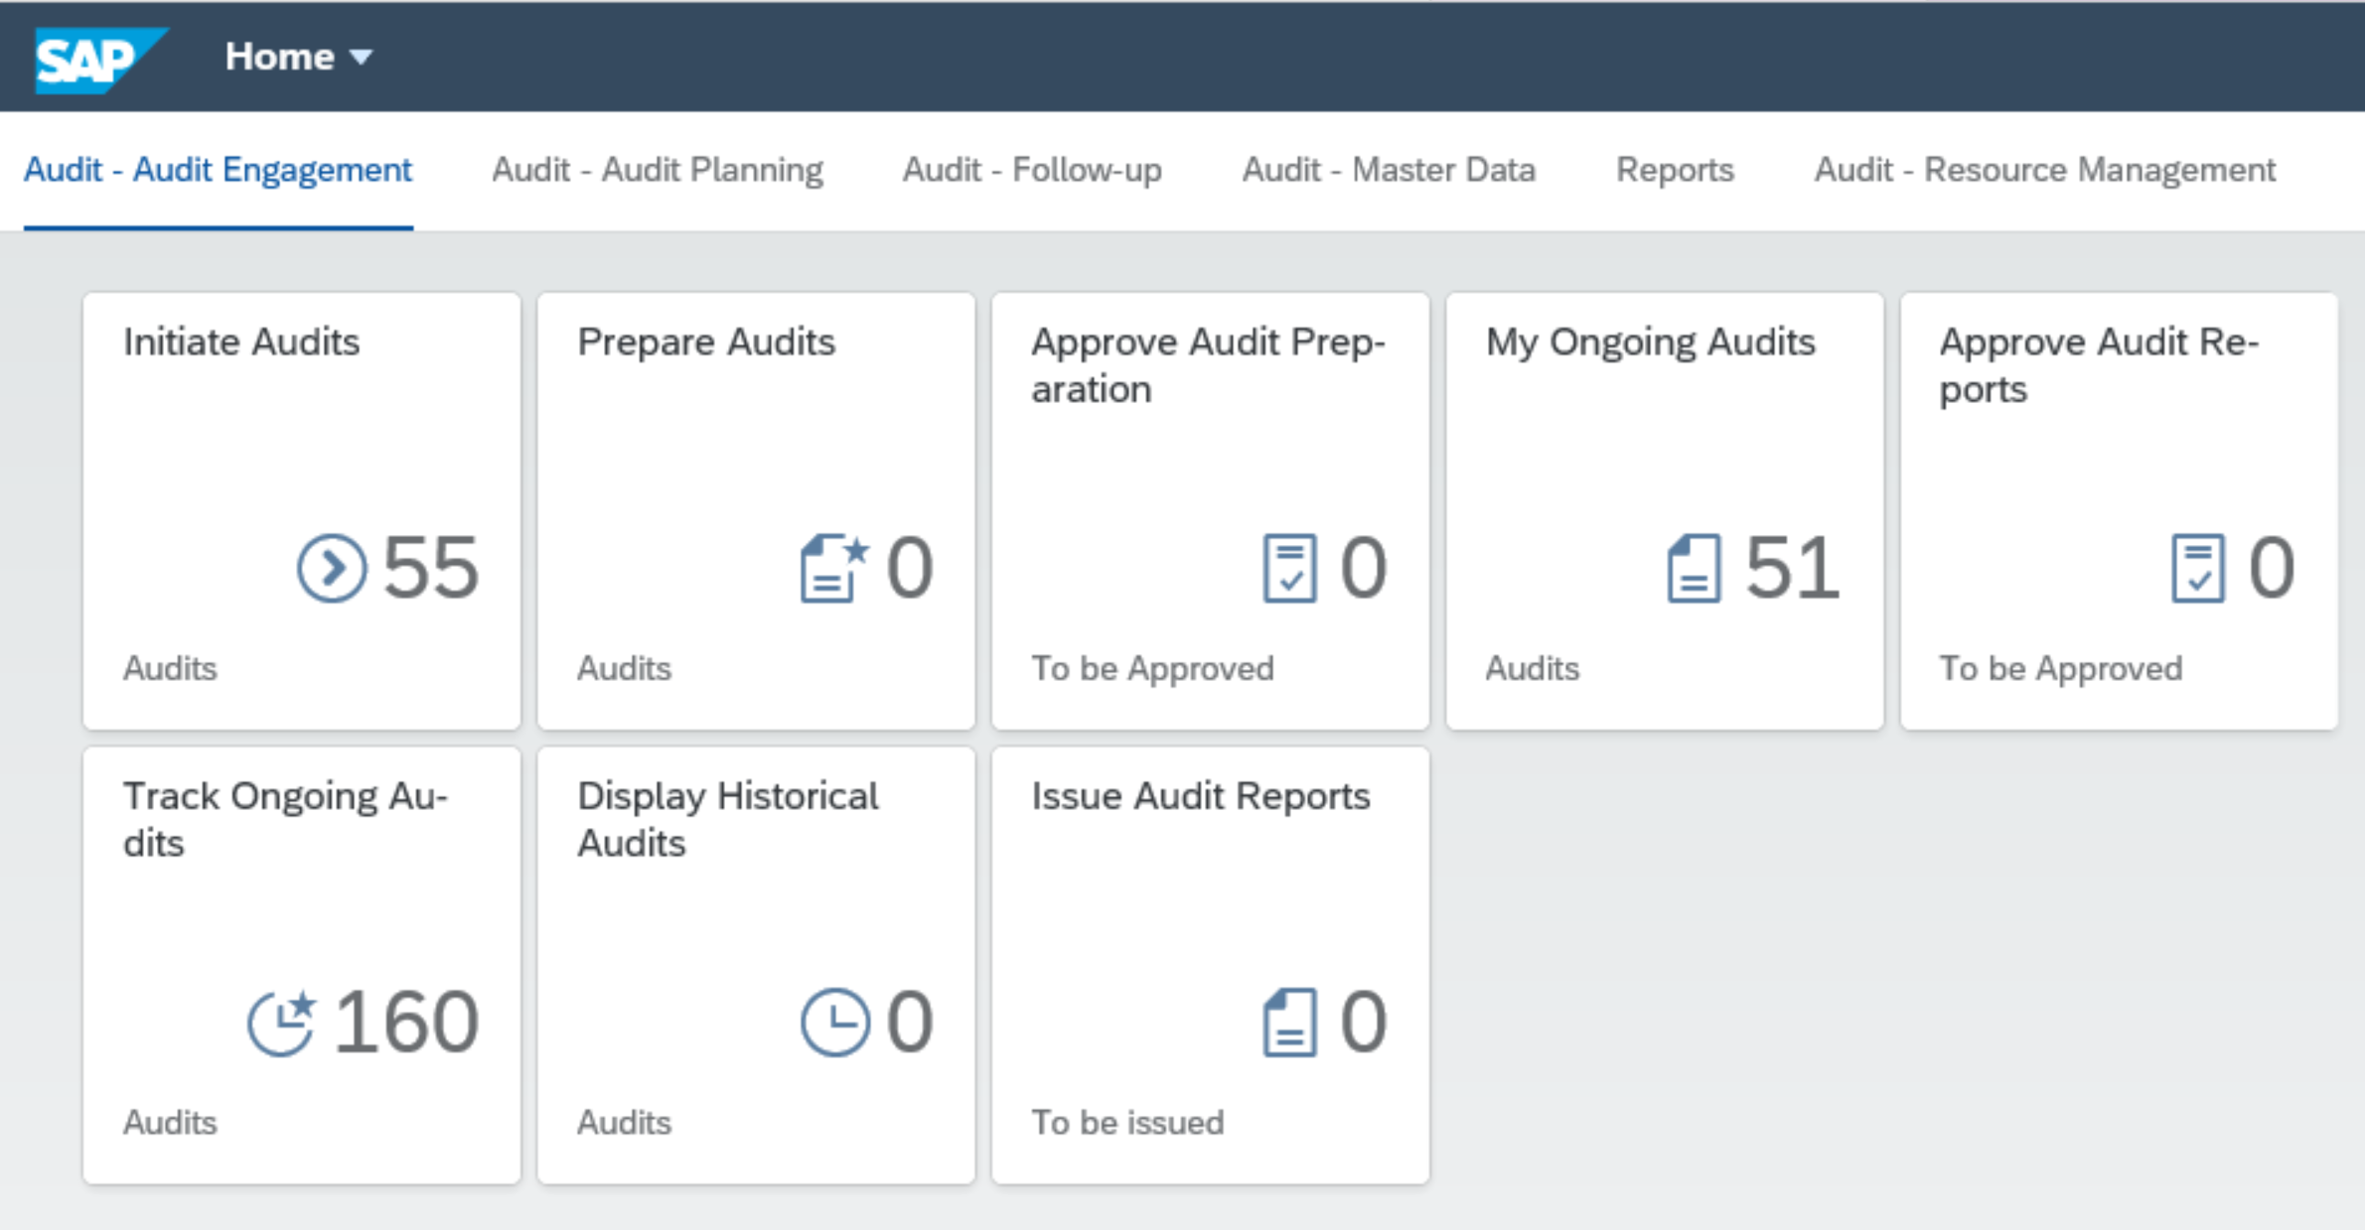
Scroll to Audit Team, click on edit and add your name as Auditor. If your name does not appear, please contact Christopher Scondo.
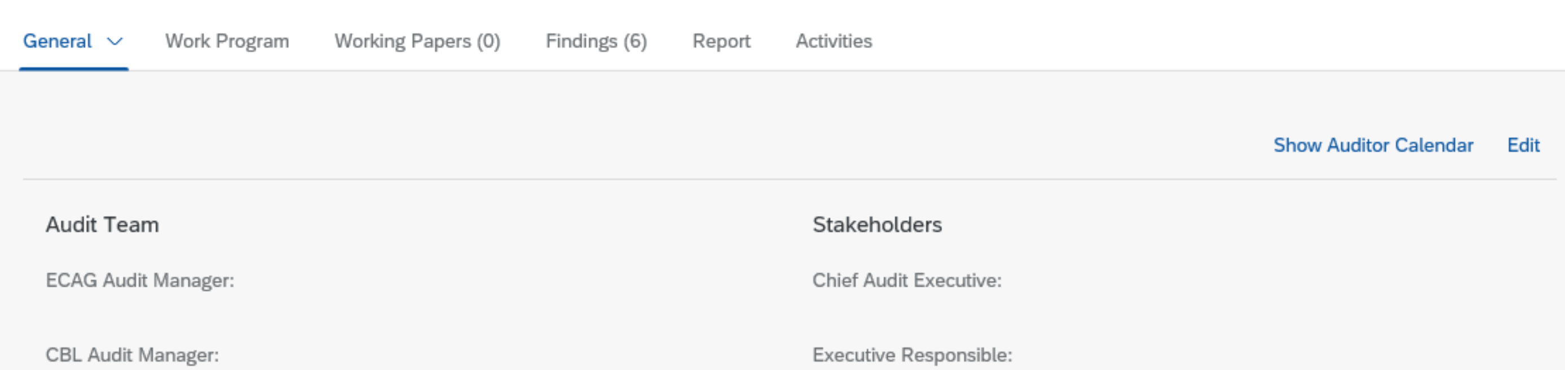
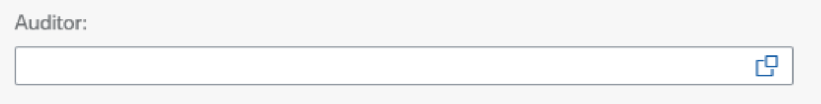
Then click on save. The audit should now appear in your ongoing audits.
- Click on “My ongoing audit” and then click on the audit you want to add findings.
- Click on Findings.
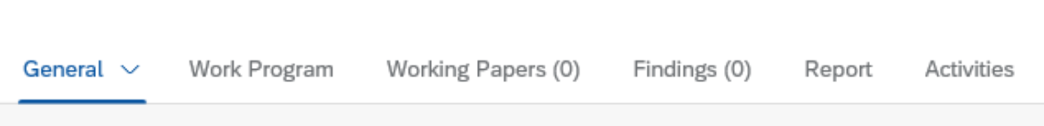
- Click on add (+).
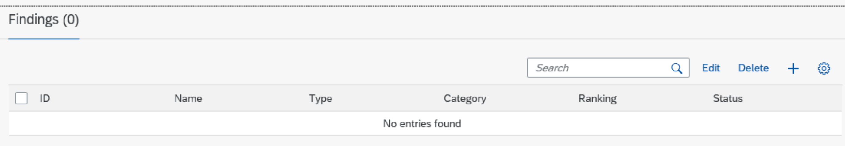
- Then complete the below fields with the information from the audit report. You will find the info in the overview table and in findings details section of the audit report. Then, click on create.
  - Title – There is a limit of 100 characters. If the title is longer, you can shorten it(use abbrevations. Please ask the AiC if needed.
  - Risk
  - Type (comment or finding)
  - Category
  - Ranking (severity)
  - Description of findings
  - Root cause – Please select the root cause provided to you by the AiC. More information available in Note 1 at the end of this Findings section)
  - Finding source (disregard, no longer needed)
  - Finding Owner Legal Entity – is always DBAG.
  - Finding tag – This field is used to enter the CSDR criteria if any for CEU, CBL and LuxCSD relevant findings (more information available in Note 2 at the end of this Findings section)
Please create the findings in the Ascending order, as the numbering is automatic and follow the order of creation. F01 then F02 then F03…etc.
Note: Due to a technical issue in SAP SAM, the Finding Description and Risk fields may swap after saving. To avoid incorrect entries, please either:
- Enter the information in the opposite fields initially, or
- Save the record and then edit it to ensure both fields are correct.

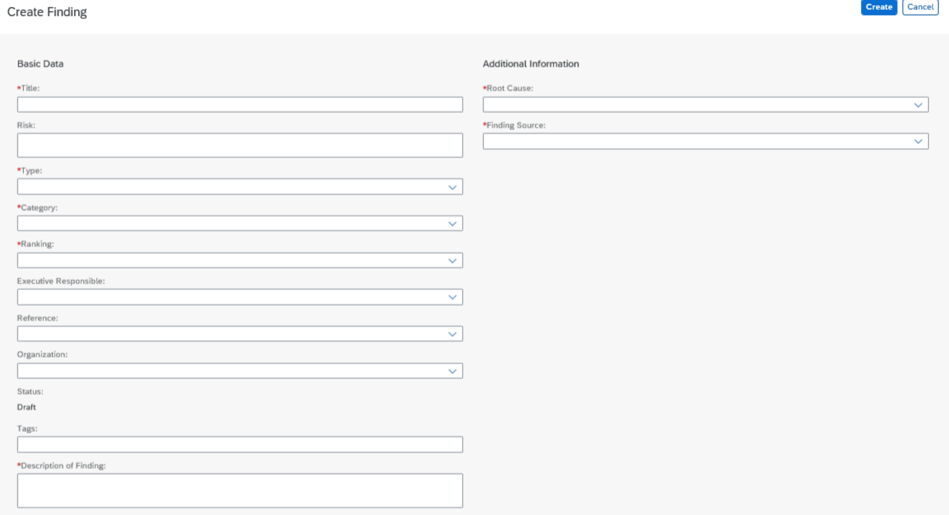
- Re-click on Findings and click on the finding you have just created.
- Add the Relevant Legal Entities and the Finding Owner. The info is provided in the overview table of the audit report. You will have to select the Legal Entity and the associated Board Member.
For all IT related findings (not only from IT audit reports but also from some business audit reports), GITA needs to be selected as relevant ‘legal entity’ based on AIC instructions)

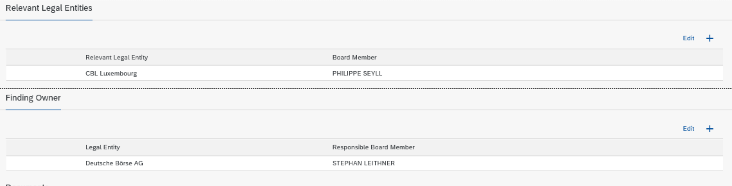

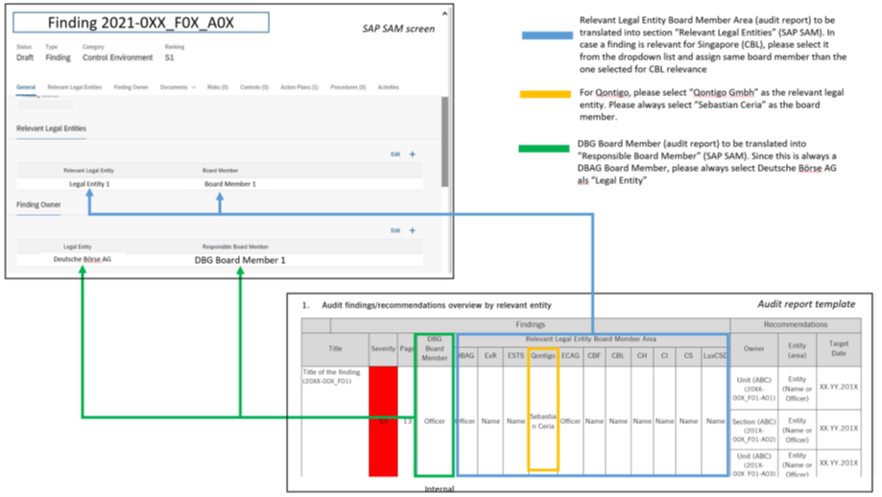

Note 1 - Root Causes
- Purpose of Root Cause Analysis
  - Helps understand why an issue occurred.
  - Guides actions to prevent recurrence and eliminate the issue.
- How to Identify Root Causes
  - Five Whys: Ask “why” repeatedly to dig deeper into organizational or system-level causes.
  - Fishbone Diagram: Visual tool to brainstorm and categorize possible causes.
- Using SAP-SAM
  - Each audit finding must be linked to one root cause from the list in SAP-SAM.
  - If no root cause fits, choose the closest match and suggest new ones to Change Agents.
- Communication & Reporting
  - Root cause must be shared with the recommendation owner during close-out.
  - Included in the audit report and SAP-SAM.
  - Mention in the executive summary if relevant.
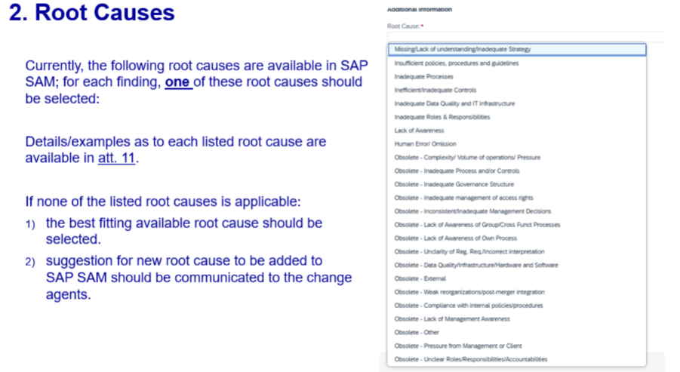
Note 2 - CSDR tags in SAP-SAM
Always check for CSDR tags in the audit report carefully while working on the SAP-SAM inputs. To be more specific, please check the ‘External/Internal Provisions’ section of the Audit Report, and input the relevant CSDR tags for each finding under the ‘Finding tags’ section on SAP-SAM.
CSDR only applies to CEU, CBL and LuxCSD relevant findings.
It is important to be careful with the CSDR tags while doing the inputs in SAP-SAM, because once the report gets issued in the tool, we can no longer make any changes in this field. The finding tag section gets frozen.
CSDR is comprised of all the below acts. Which means, we need to look for the following acts in the report while inputting the tags in SAP-SAM:
- Regulation (EU) No 909/2014 (CSDR L1)
- Commission Delegated Regulation (EU) 2018/1229 (CSDR L2)
- Commission Delegated Regulation (EU) 2017/389 (CSDR L2)
- Commission Delegated Regulation (EU) 2017/390 (CSDR L2)
- Commission Delegated Regulation (EU) 2017/391 (CSDR L2)
- Commission Delegated Regulation (EU) 2017/392 (CSDR L2)

The structure (order) we follow while inputting the finding tag is as follows: CSDR Level 1 or 2 Regulation number | Article number, sub-article (if any) | Section number (if any) | Chapter number (if any) | Title number (if any)
For your reference:
Audit Report | SAP-SAM Input
- Article 49 (4) of Commission Delegated Regulation (EU) 2017/392 (CSDR L2) | - CSDR L2 2017/392 | 49,4
- Commission Delegated Regulation (EU) 2017/392 – Article 41 (h) | - CSDR L2 2017/392 | 49,h
- Commission Delegated Regulation (EU) 2017/392, Chapter III, Section 4 | - CSDR L2 2017/392 | Chapter III | Section 4
- Regulation (EU) No 909/2014 (CSDR L1), Article 26.1, Article 26.2 | - CSDR L1 909/14 | 26,1 | 26,2

The way in which CSDR legal texts are organised:
- For the Level 1 regulation: Regulation (EU) No 909/2014: Title X / Chapter Y / Article Z.
- X is a Roman Numeral, and Y & Z are “Arabic” Numerals.
- There is no chapter in small titles. Title and chapter can be dropped in SAP-SAM if there is an article. A section is always part of the Annex. In the level 1 text, a section is always a letter. If there is a Chapter in the report, there must be a Title also.
- Illustration from the L1 text:
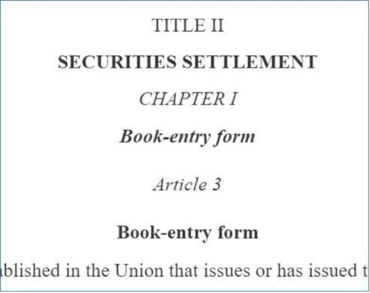
- For the Level 2 regulation: Chapter X / Section Y / Article Z.
- X is a Roman Numeral and Y and Z are “Arabic” Numerals. There is no Section in small titles. Title and section can be dropped in SAP-SAM if there is an article.
- If there is a Section in the report, there must be a Chapter also. In other words, in an L2 text, we cannot have a chapter without a section. (Refer to Special Case 2, below in the email)
- Illustration from Commission Delegated Regulation (EU) 2017/392:

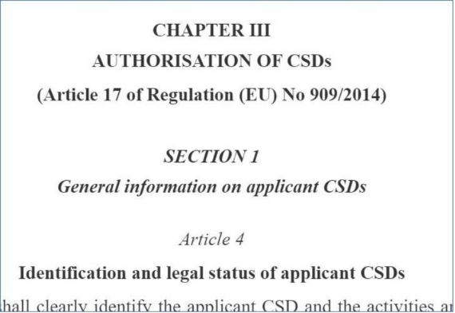

Things to remember:
- Regulation (EU) No 909/2014 is the only Level 1 act relevant to DBG findings. All the other relevant regulations are L2’s. Kindly keep this in mind, since most of the times the Audit Report has no mention of L2 even if the regulation number is clearly specified.
- Use commas (49,4) to divide the sub-article from the article, and NOT a period(49.4) or a parenthesis(49 (4)). This is as per the presentation from the GIAM, May 2024.
- Do not use the word ‘Article’ or the abbreviation ‘AT’ while inputting the information about the Article number. Kindly insert the Article number only. (Please refer to the first example from the above table)
- BUT, when there is a mention of Section, or Chapter, or Title numbers in the report, please make sure to write it entirely on SAP-SAM. (Please refer to the third example from the above table)
- The mention of CSDR tags is generally in the beginning of ‘External/Internal provisions’ section. But in some reports, some of the regulations can also be found at the end. Please make sure to check the entire box carefully.
- Please note that the order of the inputs in the ‘Tags’ section under SAP-SAM gets mixed up. The order in which you input tags under may vary from the order under ‘ SAP-SAM recommendation report’ extract.

Special Cases:
      - Most complex cases containing single Article, with multiple sub-sections are still under discussion. Information on this matter will be communicated in the future.
      - Missing information about the Chapter number, or Title number in the Audit Report.

- Whenever the entire Section is applicable to the respective Finding, ideally the audit report should contain the Chapter number for L2 regulations.
- But, a case was found in the Audit Report 2024-020, where there was no mention of the Chapter even when the entire Section was applicable to the said Finding (2024-020_F01).
- 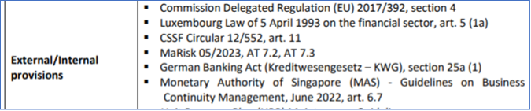
in such a case, please contact the Auditor in Charge, and request for the missing information.

2. Recommendations
- You can start creating the recommendations once the related finding has been created. Please note that in SAP-SAM, a recommendation is called an action plan. It is the same thing.

- Once you have added the Relevant Legal Entities and the Finding Owner for the Finding, click on Action Plans, then click on add (+).
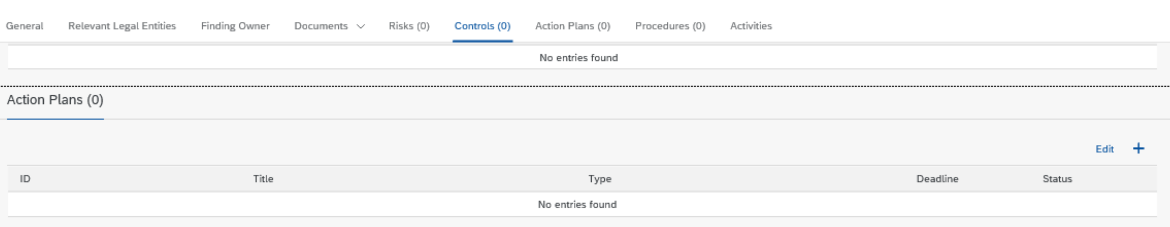
- Complete the below field with the info provided in the audit report (overview table + content detail).
  - Title
  - Type
  - Responsible auditor (this info is not in the report, but provided by the AiC)
  - Recommendation detail
  - Deadline (If the reco was closed before issuance of the report, please put 1/1/2999 as deadline)
  - Management response
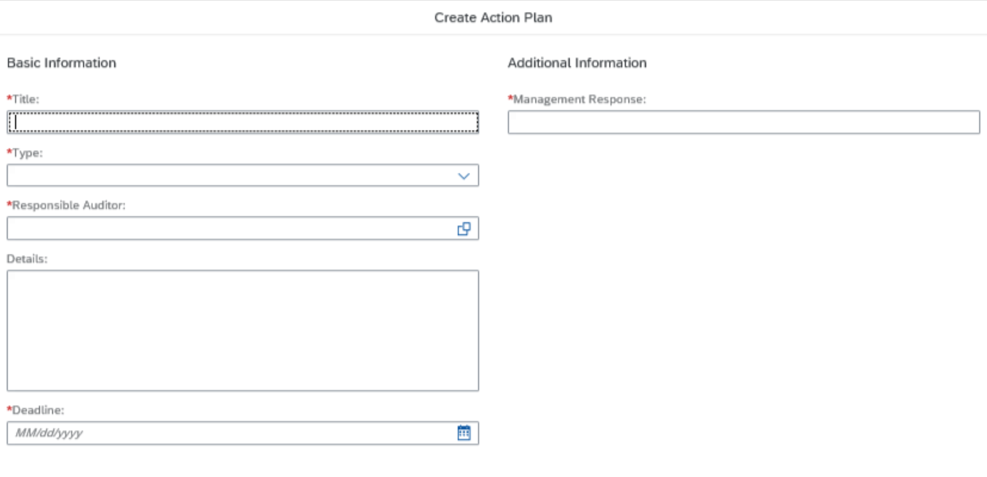

- Click on create. Then, click on the reco you have just created.
- Add the Recommendation Owner. Click on (+).
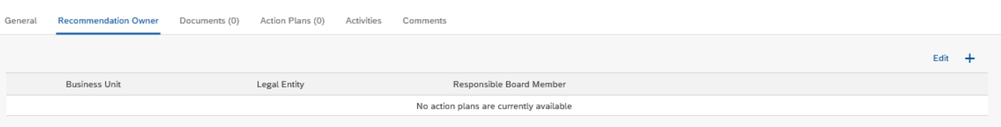

Note: Regarding selecting Recommendation Owner in SAP-SAM, only the responsible auditor can modify it, so you should follow the steps below.
- put ourself as responsible auditor first, upper right corner edit, you might need to refresh the page.
- select the recommendation owner
- remove your name and enter the responsible auditor.

- Select the correspondent Business Unit, Legal Entity and Responsible Board Member. The info is available in the overview table of the audit report.
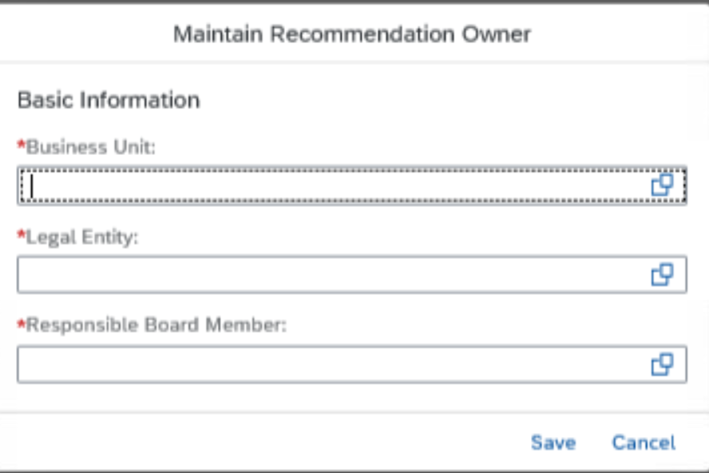

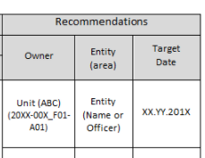

Please note that SIIs are no longer entered in SAP-SAM. Instead, SIIs are entered in the Findings Hub by the auditee.

SIIS

Please note that S1 and S2 SIIs should no longer be created in SAP-SAM. The auditees need to create them in the Findings Hub.
However, for the S3 and S4 SIIs, IA has been requested to validate these until closure so they need to be created by IA in SAP-SAM until a tracking process in implemented in the FH. They will also be created by the auditees in the FH.

Same process as for the Findings. Please select SII instead of Finding in the Finding Type field.

Comments

As per the above, for the moment all Finding mandatory fields are also required for comments. Please note that the below underlined Finding mandatory fields for Comments are not used for reporting purpose so do not waste time in finding the adequate selection, just choose the first choice available.
- Finding Title
- Finding type: Comment
- Category: Control Environment, DE, or OE testing
- Ranking: severity S1 suggested
- Description
- Root cause
- Risk: not applicable

Please note that comments will be automatically closed when the audit is issued in SAP-SAM.

When the intern is done with the input in SAP-SAM, he/she needs to
- contact the AiC so that he/she links all findings to the relevant ICS processes in the tool, in case the task is assigned to you by AIC then steps to follow SharePoint
- When this is done, the intern will contact &IA_Reporting asking for another intern to perform the Data Quality Check (DQC) in SAP-SAM before the issuance of the audit report. The check helps make sure what is written in the report matches what is entered in SAM. If discrepancies are identified, they can be fixed at this stage.

Thank you for your much appreciated support

